**Time series of La Niña and El Niño events 图表

AI 生成的内容可能不正确。**

**The following results analyze the statistical results under the condition of p<0.05 in different time periods:**

1. **The entire period from 1999 to 2024**

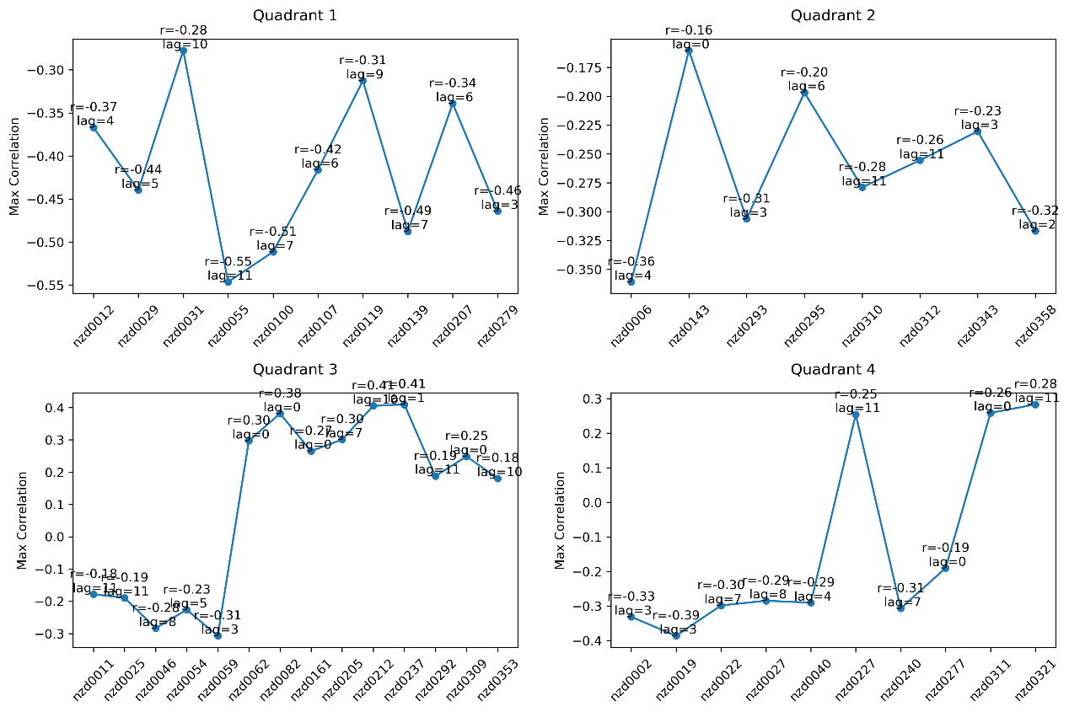From 1999 to 2024, the correlation between shoreline changes and the Southern Oscillation Index (SOI) shows clear spatial differences:

* **Quadrant 1 (northeast-facing)** beaches exhibit a moderate negative correlation (ranging from -0.28 to -0.55), with lag times spread between 3 and 11 months.
* **Quadrant 2 (southeast-facing)** shows generally weak correlations; most results are not statistically significant. Only two sites have significant correlations with absolute values greater than 0.3, and their lag times are 2 and 4 months.
* **Quadrant 3 (southwest-facing)** shows a transition in correlation with latitude — from negative in lower latitudes (-0.2 to -0.3) to positive in higher latitudes (mostly 0.3 to 0.4). Lag times are more scattered.
* **Quadrant 4 (northwest-facing)** follows a similar latitudinal trend. Except for one site (nzd0240 and nzd0277), stronger negative correlations (close to -0.3) are found in the northern areas, with lags of 3, 4, 7, and 8 months. Positive correlations (around 0.26–0.28) appear mainly on the west coast of the southern North Island, with lags at 0 and 11 months.

Overall, **the west coast** tends to shift from negative to positive correlation as latitude increases. **The east coast** consistently shows negative correlations, with **northeast-facing shorelines** being more strongly influenced, while **southeast-facing ones** show weaker responses. Lag times are scattered across both coasts.

1. 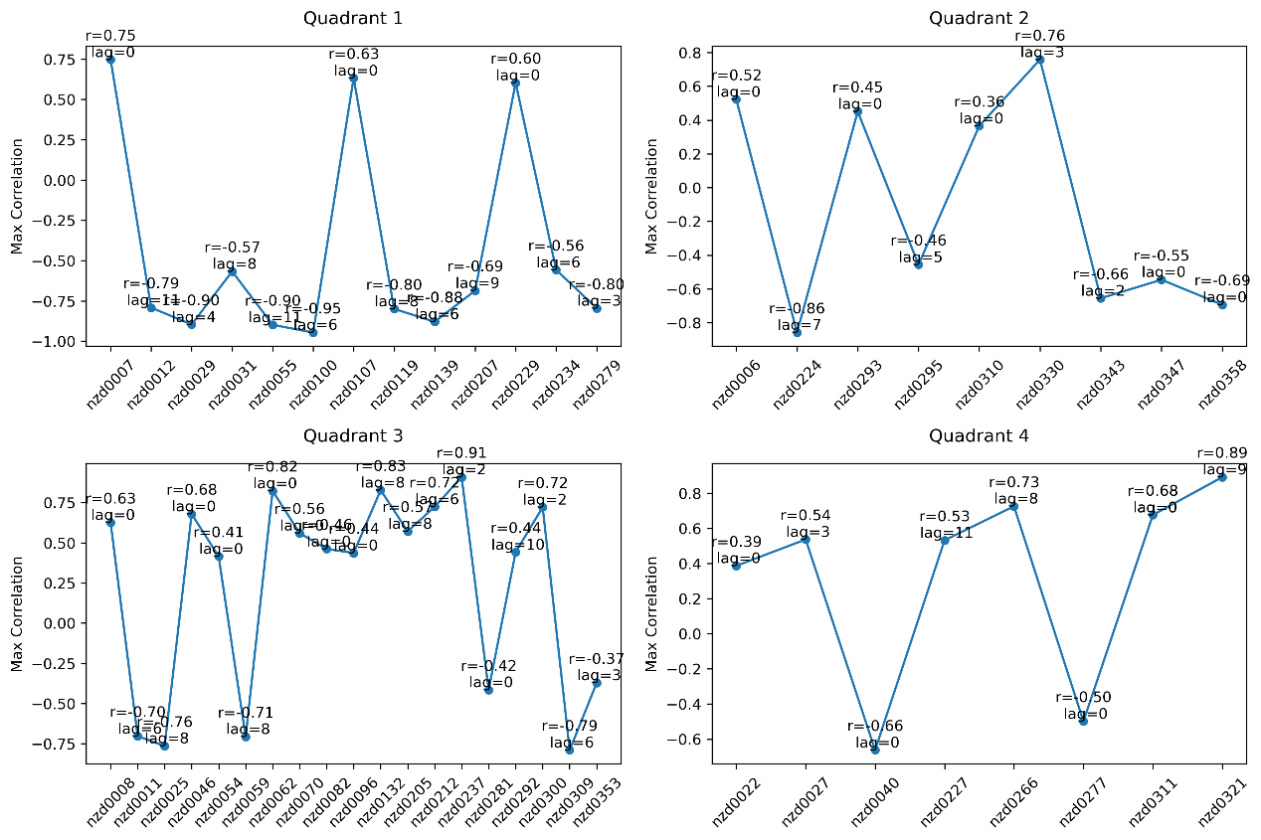 **La Nina period (2010.6.1 – 2013.12.31)**

During La Niña events, In the first quadrant (northeast-facing coasts), there is a strong negative correlation overall, with correlation coefficients mostly ranging from -0.57 to -0.95, and lag times concentrated between 3 and 9 months. In the second quadrant (southeast-facing coasts), the direction of correlation varies, and the lag times are more scattered, ranging from 0 to 7 months.

In the third quadrant (southwest-facing coasts), the correlations are mainly positive (r = 0.41–0.91), while negative correlations occur mainly at the northernmost and southernmost sites, with lag times centered around 0, 6, 8, and 10 months. In the fourth quadrant (northwest-facing coasts), positive correlations also dominate (r = 0.39–0.89), with only two sites (nzd0040 and nzd0277) showing negative correlations. The lag times are distributed at 0, 3, 8, 9, and 11 months.

These patterns indicate that La Niña events influence coastlines differently depending on their orientation, with clear spatial and temporal variations in response.

1. 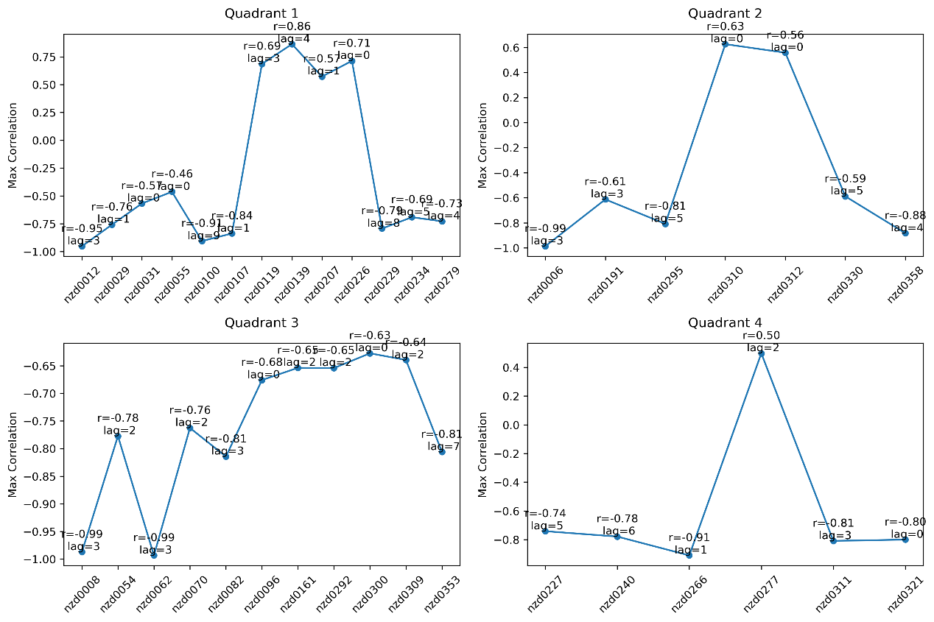 **The period of El Nino (2015.1.1 – 2016.12.31)**

During El Niño events, the relationship between the coastline and related factors shows distinct spatial and temporal (lag) differences.

In the first quadrant, most sites exhibit negative correlations (ranging from -0.46 to -0.95), but the mid-latitude region shows significant positive correlations (0.69–0.86), with generally short lag times (less than 3 months). The second quadrant shows a similar pattern to the first: negative correlations are concentrated at the northern and southern ends, while positive correlations mainly appear in the middle, though this middle region is located at higher latitudes compared to the first quadrant. Lag times are generally less than 5 months.

In the third quadrant, there is a strong overall negative correlation (ranging from -0.63 to -0.99), which is the opposite of the pattern observed during La Niña, and lag times are typically short (under 3 months), with only one site (nzd0353) showing longer delays (7 months). In the fourth quadrant, most sites also show negative correlations (ranging from -0.74 to -0.91), except for nzd0277, which shows a positive correlation. Lag times in this quadrant are all under 6 months. Overall, El Niño events tend to have a predominantly negative impact on the coastline, with shorter response times and clear regional differences.

1. **Conclusion**

Both La Niña and El Niño events show significant spatial and lag-related effects on coastline changes, but their patterns differ notably.

1. In the first quadrant (northeast direction), both events mainly show negative correlations, but during La Niña, the correlations are stronger and the lag times are longer (4–9 months). In contrast, El Niño shows positive correlations at mid-latitudes with shorter lag times (less than 3 months).
2. In the second quadrant (southeast direction), La Niña shows mixed patterns with both positive and negative correlations and scattered lag times (0–7 months). During El Niño, however, the pattern is like the first quadrant, with positive correlations in the central region and negative correlations in the northern and southern areas. Lag times are mostly within 5 months.
3. The third and fourth quadrants (west coast) show the most distinct differences: La Niña is mainly associated with positive correlations (r = 0.39–0.91), while El Niño is strongly negatively correlated (ranging from -0.63 to -0.99), showing an opposite trend. El Niño also has shorter lag times. Notably, the coastline at station nzd0277 shows a response opposite to that of most other sites during the same period.